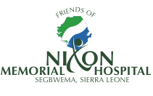

*Welcome to this edition of the “Friends of Nixon” newsletter, updating you with news from Nixon Memorial Hosptial, Segbwema, Sierra Leone and highlighting some of the progress and activities initiated by the charity in support of the hospital.*

In this issue:

* Hospital Update: Ebola & Moving Forward
* Infection, Prevention and Control Workshop
* FoN sponsored Staff
* Update on Latrines project
* Obstetric Teaching
* Personal Reflection of a Voluntary Doctor
* Donations

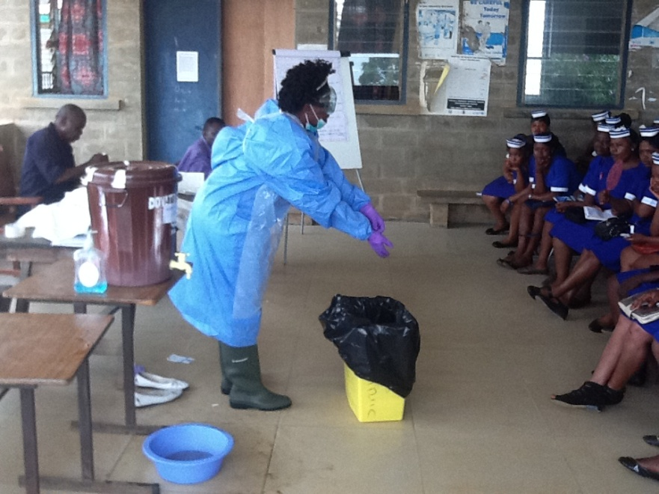

*Training delivered at a recent Infection, Prevention & Control Workshop*

Friends of Nixon

Update

Newsletter MAy 2015 Registered Charity 1145455





**Hospital Update: Ebola & Moving Forward**

The hospital has faced a very difficult 12 months, with the Ebola epidemic having major consequences on the hospital, its staff and the people it aims to serve. Very sadly the hospital lost 5 staff members to Ebola, including 4 nurses. This, together with the passing away of the hospital’s long serving theatre master, Stephen Juanah, early last year after a short illness, had a significant impact on the ability of the hospital to meet the healthcare needs of Segbwema and its surrounds. During the epidemic the Nixon nursing school was closed and activity at the hospital has been limited, in part due to the community’s mistrust of all healthcare institutions and misunderstandings regarding Ebola. This had major financial implications on the hospital due to the loss of its two main revenue streams: nursing student fees and nominal patient fees.

Although the Ebola outbreak had tragic direct consequences, it highlighted the fragility of health care structures across Sierra Leone and the severe limitations within these systems, of which Nixon Hospital was not exempt. In addition, the local economic consequences, in part from travel restriction, family losses and closure of all schools and education establishments for most of the year will take a considerable time to resolve.

The hospital is now beginning to move forward. The nursing school re-opened in April following an Infection, Prevention & Control workshop funded by Friends of Nixon (see below), the hospital’s community work focusing on latrines and sanitation has restarted and the numbers of women delivering their babies on the maternity ward continue to increase, partly as a result of a partnership with Marie Stopes International.

There has been much generosity from donors in response to the epidemic but ensuring that the hospital becomes sustainable remains key to its future. The plans it makes with its stakeholders including the Methodist Church of Sierra Leone, the local community and the Government of Sierra Leone, as well as its partnerships with local non-governmental organization and its overseas supporter including the Methodist Church in the UK, will be central in determining both its longevity and its effectiveness in providing healthcare to those that need it most.

“Friends of Nixon” looks forward to continuing to support the hospital’s development with its focus on community health work, training, education and infrastructure support.

[www.friendsofnixon.org.uk](http://www.friendsofnixon.org.uk)

,   
so spend a moment to explain what’s really going on   
in graphs and photographs.

**Infection, Prevention and Control Workshop**

As part of efforts to help re-initiate activities at the hospital site including the re-opening of the nursing school, Friends of Nixon funded a 2 day workshop in April 2015 for all staff and students on infection, prevention and control.

This was delivered by staff from the Lassa Fever Team at Kenema Hospital, a WHO representative and community health care workers. It included sessions on viral haemorrhagic fevers, (the group of disease that Ebola belongs to) as well as practical approaches to infection control including use of chlorine, hand washing and disinfection and waste disposal.

It is hoped this will help improve the safety of nursing students, patients and staff in the future.

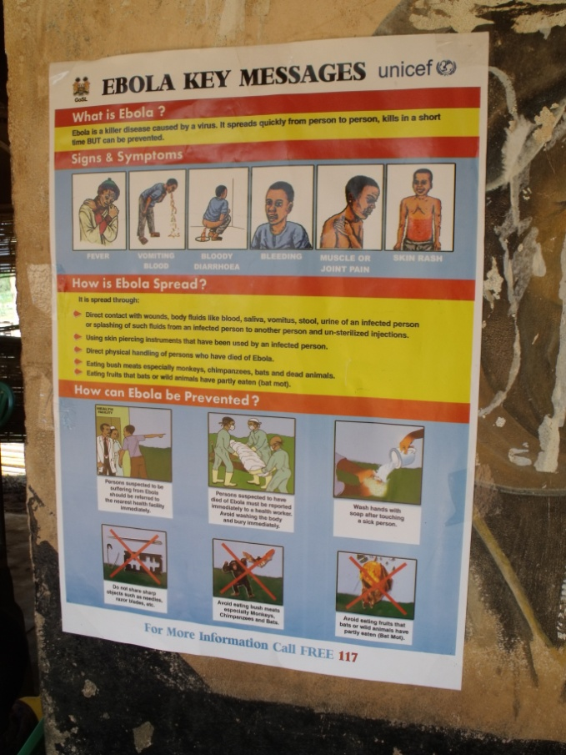

*A poster in Segbwema highlighting the key messages to prevent the spread of Ebola.*

**FoN sponsored Staff**

Although their studies have been interrupted due to the Ebola epidemic, the three nursing staff who Friends of Nixon are sponsoring through further training have completed their first year of their courses. Cecilia Kabba and Fatmata Conteh have completed their first year of midwifery training at Makeni University, with Sarra Kamara completing his first year of Community Health Office training at Njailahun University. We look forward to the future when their new skills can help the hospital providing the healthcare service its population needs.

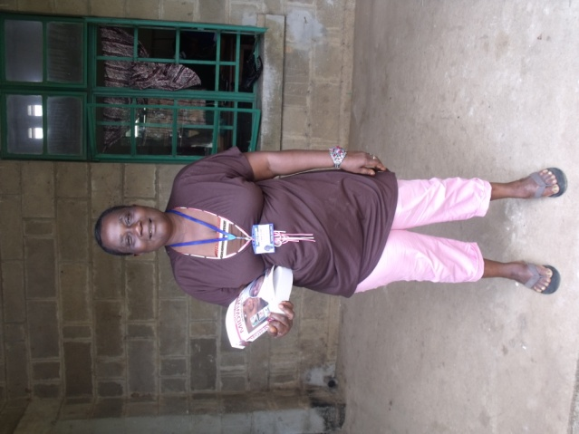

*Nurse Fatmata Conteh with a donated copy of Myles Midwifery when I caught up with at Nixon after her first semester at Makeni University.*

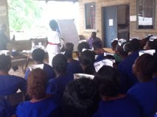



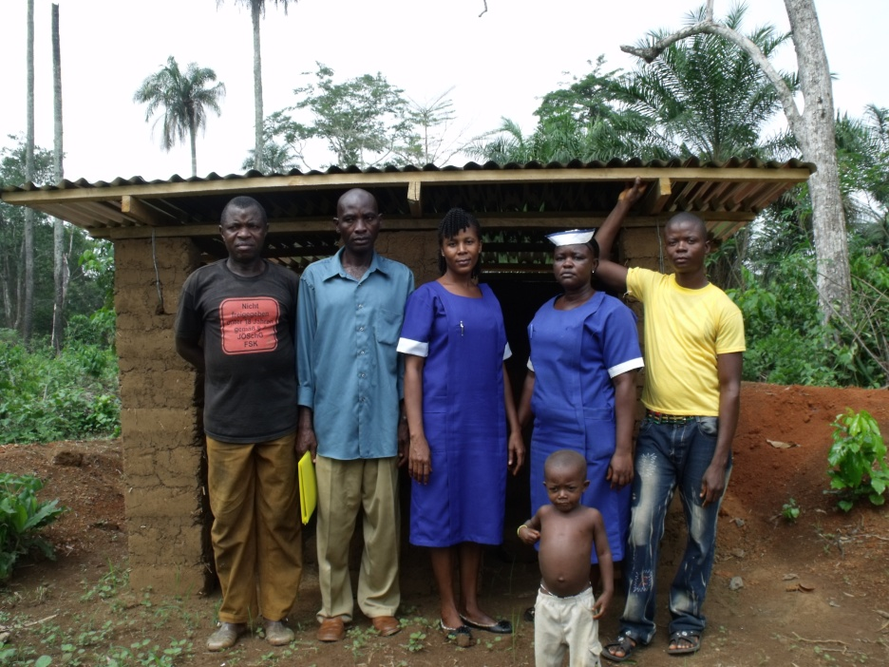

*Nixon students on placement in Ngokolu village with one of the village’s new latrines.*

Friends of Nixon has always been keen to support the hospital’s community health work which aims to begin to address some of the core determinants of poor health including inadequate sanitation. Part of the ongoing work the charity is supporting includes the building of latrines in the villages surrounding the hospital. The use of latrines reduces the transmission of water borne diseases and acts as a focal point for the hospital’s community health education work.

The first phase of 4 villages completed all of their latrines prior to the Ebola epidemic and now the community health team are working with the villages in phase 2 of the project which includes construction of a further 22 latrines. As before, the charity is providing the funds for materials and the individual communities invest their labour and time into the project ensuring a shared partnership.

Friends of Nixon have, in addition, donated funds to enable the purchase of 1 new motorcycle and the repair of one existing motorcycle to enable staff access to the villages to continue this health work.

*Thomas Momoh, Head of Community Health work at Nixon Hospital (Far left) with people from Malehun village outside their (almost) finished latrine.*

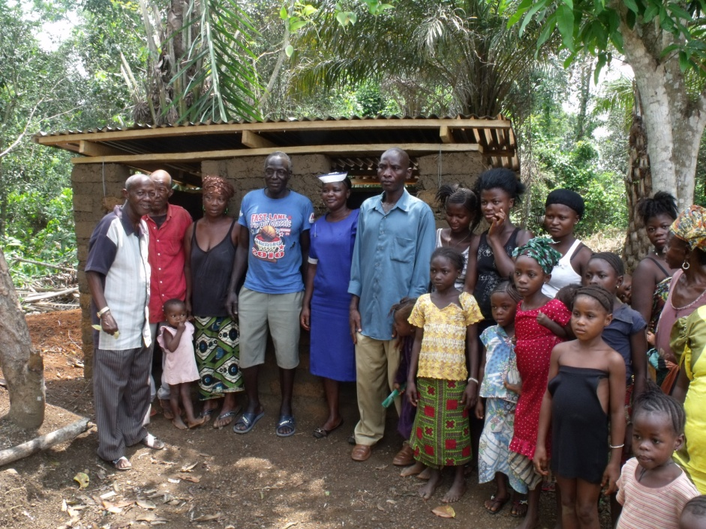

**Update on Latrines project**

**Thank you for your ongoing support**

**If you wish to donate please contact:**

**Mr Robert Dixon (Treasurer for FoN), 11a Denbigh Road, London, W11 2SJ**

**Email: ROBERT.DIXON@HOTMAIL.COM   
Website:**[**www.FriendsofNixon.org.uk**](http://www.friendsofnixon.org.uk/)

**Trustees are more than happy to consider speaking on the work of the charity**

**Donations**

We are very grateful to donations received over the course of the last 12 months and we are very thankful for the generosity of those who wish to support the hospital. Whilst there is naturally a significant amount of work needed at the hospital, it is a relatively small institution within Sierra Leone, attempting to find its feet and resolve some issues of sustainability after a difficult year. Therefore, currently, it is perhaps not best placed to administer large sums of money of in relation to the post-Ebola response. As we are always keen to ensure donor’s money is used appropriately and for its intended cause, if you are wishing to donate specifically to a wider response to the Ebola epidemic, other larger non-governmental organisations such as MSF may be more appropriately placed to coordinate such work. However, we undoubtedly continue to appreciatively welcome donations for the current and future ongoing work Friends of Nixon is supporting at the hospital to provide good quality healthcare to the people of Segbwema.

”

**Obstetric Teaching**

In June 2014 funding through funding through Friends of Nixon enabled a 4 week workshop to take place for all students and staff at the hospital focusing on the practical management of obstetric emergencies. Participants took part in interactive lectures and simulation sessions to gain experience in knowing how to manage the basics of the major causes of death in pregnancy and child birth in Sierra Leone (Bleeding, Infection, Eclampsia (seizures) and obstructed labour). Knowing the fundamentals of these common problems is key for the nursing students who may find they face such problems after they qualify when they are based at community health centres. To compliment this training, a donation of basic maternity equipment including blood pressure equipment, vacuum delivery sets, foetal Dopplers and stethoscopes was made to the hospital to assist in the delivery of safe maternity care.

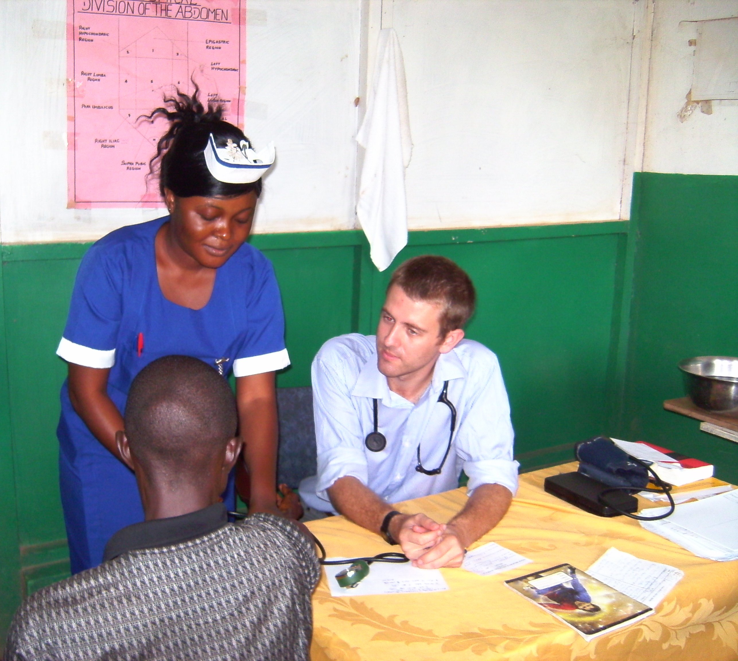

**Personal Reflection of a Voluntary Doctor**

I returned from working as a doctor at Nixon from August 2013-June 2014. During my time at Nixon I was grateful for the support Friends of Nixon were able to give to the hospital including funds to repair a hospital vehicle, a significant investment in medicines for the hospital pharmacy, and fund new folders for all inpatient charts (a small but immeasurably useful addition). Although notably out of date, my blog can be viewed at http://healthmattersinsegbwema.blogspot.co.uk/.

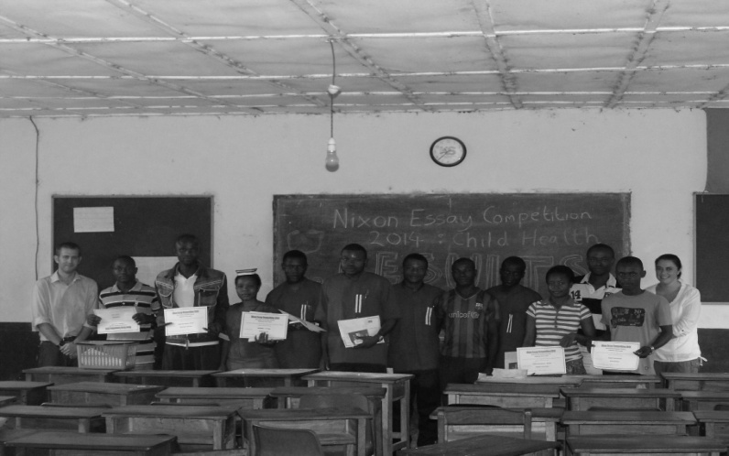

*A selection of nursing students receiving certificates for an essay competition after one of their obstetric workshops.*



Newsletter May 2015 Registered Charity 1145455